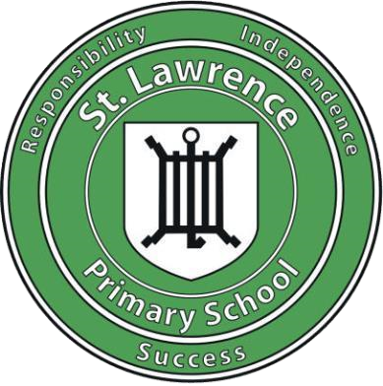

Computing Policy

Our Mission:
'To develop responsible, independent individuals who love learning and have the knowledge and attitudes to be successful in an ever-changing world'.


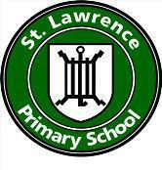
St. Lawrence Primary School
Computing Policy

As a Rights Respecting School, our philosophy is underpinned by the values and principles of the United Nation’s Convention on the Rights of the Child (UNCRC).
Articles from the UNCRC which are directly linked to the Computing curriculum at St. Lawrence School:
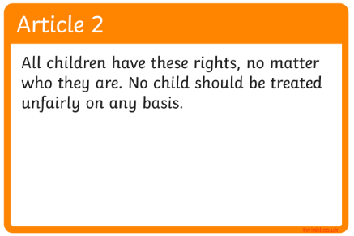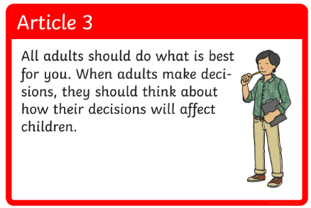
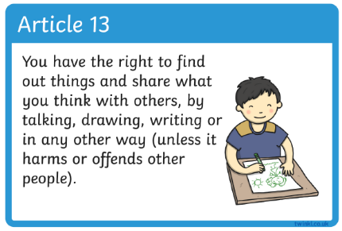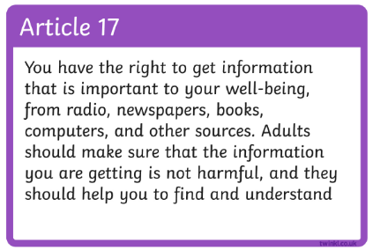
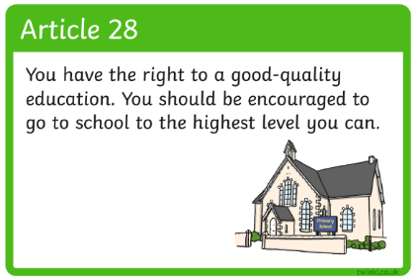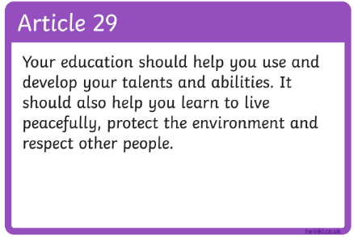

As Duty Bearers, it is our responsibility to teach children their rights. This is done predominantly through PSHE sessions. Children learn about their rights, through their rights and for their rights. Staff and young people have an understanding that rights are inherent, inalienable, indivisible, universal and unconditional, using language appropriate to children and young people’s age and ability.

Contents

- Vision
- Planning
- Computer Science
- IT skills
- Digital Literacy
- SMSC in Computing
- Oracy in Computing

Vision
At St Lawrence Primary School, we aim to develop responsible, independent individuals who love learning and are equipped with the knowledge, skills, and attitudes necessary to thrive in an ever-changing world. Computing plays a crucial role in this, empowering children to use computational thinking and creativity to understand and shape the world around them.
A high-quality Computing education ensures that students not only become digitally literate but also develop the ability to express themselves, solve problems, and explore ideas through the use of information and communication technology. This prepares them for the future workplace and encourages active participation in an increasingly digital society.
We believe that Computing enhances learning across all areas of the curriculum. It provides students with unique opportunities to engage in activities—such as multimedia projects—that would be difficult to achieve in any other way. Through Computing, pupils can access a wealth of information and resources instantly, and they can collaborate with others, building essential communication and negotiation skills.
At St Lawrence, we recognise that Computing supports diverse learning styles, whether visual, auditory, or kinesthetic. By integrating technology in a meaningful way, we aim to inspire creativity, critical thinking, and lifelong learning, preparing our students for success in both their academic journey and the digital world beyond school.

Planning
At St Lawrence School, we follow the Jersey Curriculum for Computing. There are three strands within this curriculum:
- Computing Science
- IT Skills
- Digital Literacy
Computer Science is the ‘foundation’ of the subject (i.e. the underlying principles that make up the subject). Computer Science covers the ‘how’. How computers and computer systems work and how they are designed and programmed. Computer Science covers the programming units for each year group where pupils are taught to create and debug simple programs and to use logical reasoning to predict the behaviour of simple programs.
IT Skills are about how to ‘apply this knowledge’ and to gain the understanding to purposefully create and make things. Within this strand, teachers cover a variety of media such as video, audio, art, photography or music. Pupils are taught to use technology purposefully to create, organise, store, manipulate and retrieve digital content. In KS2, pupils are taught to collect, analyse, evaluate and present a range of data and information.
Digital Literacy is about the understanding and implications and why we are choosing to use something for a particular purpose. Pupils are taught to how to understand computing networks, including the internet and know how they can use multiple services, as well as the opportunities these services can offer for communications and collaboration. This strand also covers Online Safety - knowing how to use things safely, respectfully and responsibly. The following link provides parents with Digital Safety information, and we offer support to parents around digital safeguarding. https://www.purplemash.com/app/code/docs/Saferinternet_parentinginadigitalworld_2019
We use the Purple Mash scheme of work to support curriculum delivery. Purple Mash is an online learning platform that teaches computing to primary school children through creative tools, coding, and themed activities. We also use the 2BeSafe aspect of this scheme to support our delivery of Digital Safety within the classroom.
The Jersey Computing Curriculum has been set out with objectives in distinct Key Stages and at St Lawrence School, we have created plans for each year group, ensuring that these objectives are covered and consolidated. There are times when we have discrete Computing lessons to teach skills (such as when teaching coding, or Office-based skills) as well as cross-curricular opportunities to develop these skills and enhance learning in other curriculum areas, for example, when collating information in Science, or when researching a historical topic.

SMSC in Computing
Moral
At St Lawrence School, our Computing Curriculum builds children morally by:
Encouraging good etiquette when using digital technology including mobile devices and with due regard to e-safety.
Encouraging respect for other people’s views and opinions.
Exploring moral issues around the use of digital technology, for example, copyright and plagiarism.
Teaching children about cyber-bullying and what to di if it happens to themselves or a friend.
Spiritual
At St Lawrence Primary School, our Computing Curriculum builds a child spiritually by:
Exploring creativity and imagination in the design and construction of digital products.
Promoting self-esteem through the presentation of children’s work to others.
Exploring how ideas in Computing have inspired others.
Creating digital products which incorporate children’s beliefs.


Cultural
At St Lawrence School, our Computing Curriculum builds a child culturally by:
Encouraging the sensible use of digital technology in the classroom and homework situations as children are living in a digitally cultural environment.
Empowering pupils to apply their IT and Computing Skills and knowledge to the wider curriculum and acknowledge links between subjects.
Social
At St Lawrence School, our Computing Curriculum builds a child socially by:
Encouraging students to assist one another in problem solving.
Encouraging appropriate social behaviours in the classroom including listening whilst others are talking and generally interacting as a caring community.
Encouraging good practice and respect in the use of social networking.

Oracy in Computing
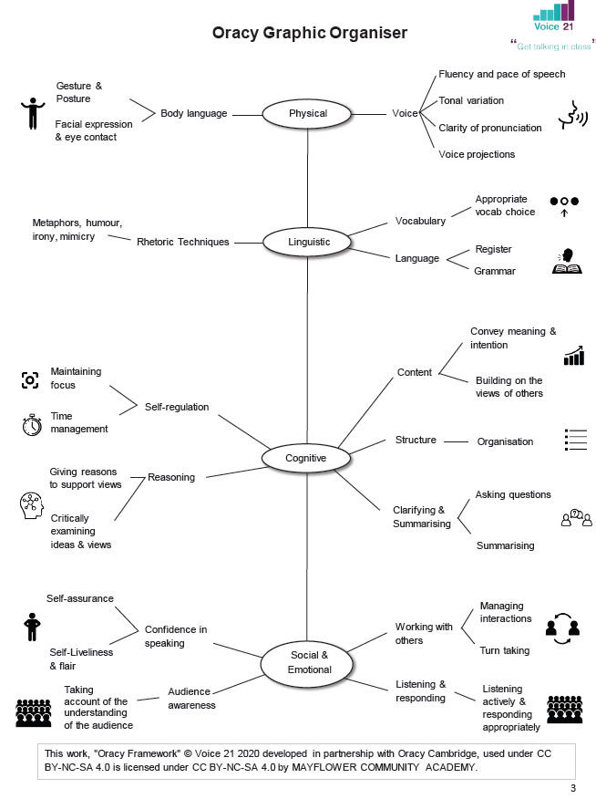

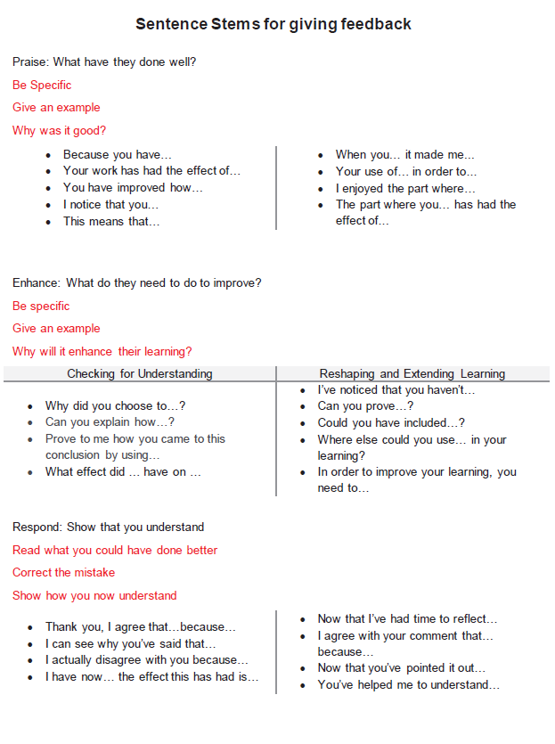

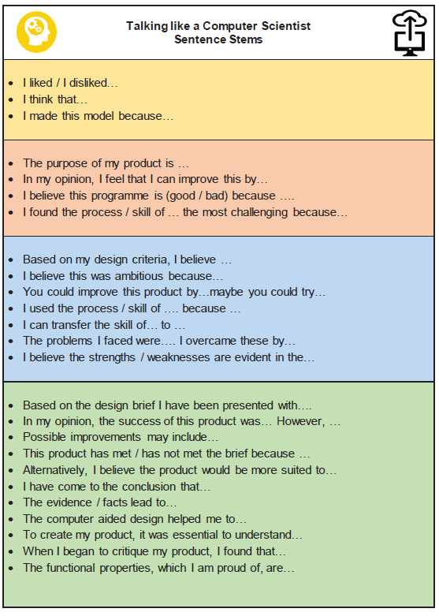

Version | Date Issued | Issued by | Reason for Change |  | Presented | Approved by: |  | Date
0.1 | September 2014 | Kim Banks |  | New Comptuting Curriculum | Staff Meeting |  | All staff |  | Sept 2014
0.2 | September 2018 | Kim Banks |  | Updated planning | 1:1 meetings with all staff |  | All staff |  | Sept 2018
0.3 | March 2023 | Kim Banks |  | Updated policy | Staff Meeting |  | All Staff |  | March 2023
0.4 | May 24 | Kim Banks |  | Oracy in Computing | Whole Staff |  | Whole Staff |  | May 24
0.5 | November 2025 | Kim Banks |  | Adding details about Purple Mash and 2BeSafe | Whole Staff |  | Whole Staff |  | Nov 25

